## Principles of the Loop Antenna

A loop antenna is an antenna primarily for the AM broadcast and the Long wave bands. There are two different types of loop antennas, one is the ferrite bar, the other is wound on an air core form. A loop antenna is very directional. The pickup pattern is shaped like a figure eight. The loop will allow signals on opposite sides to be received, while off the sides of the loop the signal will decrease or be nulled out. The nulling feature will allow you to remove a local station on a frequency and pick up another on the same frequency by removing the local signal. A loop may have an amplifier or may not.

Air core loop antennas come in many sizes. The larger the loop the more gain there is. A small loop will actually lose part of the signal. That is why most small loops will use an amplifier. There are two ways a loop can be wound, box or spiral. In the box or solenoid loop the plane of the winding are wound perpendicular to the diameter of the loop, so each loop is the same size. In the spiral loop the plane of the windings are wound parallel with the diameter of the loop, so each loop gets smaller as you wind into the center of the loop. A loop needs to be able to rotate to null out a station. And a loop also needs to be able to till from vertical. This also helps in nulling of a signal.

The number of turns the loop needs is determined by the size of the loop, the frequency range that you want to tune and the value of your tuning capacitor. The larger the loop the fewer turns you will need. A 4 foot loop needs 8 turns and a 2 foot loop needs 18 turns. The capacitor that is used is the standard AM tuning capacitor with a range of 10 to 365 pf. The tuning capacitor is used to tune the loop to the frequency that you want to listen to. When you are tuned in to the frequency the signal will peak. You may not be able to tune the full frequency range that you want to tune. So you will need to use a 2 section capacitor and switch the second section in. (more capacitance)

#### There are three ways to connect loop antenna to radio.

One way is not connecting it at all. (This requires a portable radio with an internal loop antenna.) The field of the loop will radiate the peaked signal and it is possible to pick it up with no connection to the radio. One can move the radio around to get the best reception.

One can also direct couple to the loop. This way it is possible to connect to each end of the loop and also to the center tap of the loop. Using this method there is a need to use it with an amplifier.

The last method is to use a pick up coil. This consists of one turn of wire that is placed inside the loop on the cross arms. This is then connected to the radio. The distance from the main tank coil can be determined by using a pocket radio and moving it inside the loop to find the place were the signal is strongest, and where it peaks sharpest.

## 

## What is a loop and why use it?

A loop antenna is a small multi turn loop of less than 1/10th wavelength in length. The loop is wound on a form, which may be either box (solenoid), or spiral (pancake) wound. The core material can either be air, or a powdered iron compound (Ferrite). The gain of a loop is much less than a longwire, but it has much less noise pickup. A properly designed Loop primarily responds to the magnetic component of the radio wave. Note that noise resides primarily in the electrical component. A vertical antenna responds mainly to the electrical component.

#### Why use a loop?

A) No available space for a longwire antenna

B) To eliminate unwanted signals, and noise

C) Radio Direction Finding

D) To improve the performance of a simple receiving system, by providing pre-selection which improves image rejection, and adjacent channel selectivity.

#### Electrical Design Characteristics

Two main types of Loops available 1). Directly Coupled and 2). Indirectly coupled (Transformer coupled) The Directly Coupled Loop has its windings directly attached to an Amplifier. Usually the main Tank Coil (parallel tuned circuit that forms the loop primary) in the loop is grounded at the center of the winding (center tapped), to allow for electrical balancing. The Amplifiers are usually but not always J-FET’s, with 2 FET’s in a Differential configuration, where the ends of the tank winding go to each FET gate. The Transformer coupled version uses a link winding to couple the signal to the receiver. This version can be amplified or non amplified.

The pick up pattern of a properly designed loop should be a figure 8 pattern. The null should be of the same depth, if the antenna is rotated 180 degrees horizontally (loop should not be adjusted for alt-azimuth, but left vertical 90 degrees from the ground). The 180 degree symmetry should be the same + or - one degree. If this condition does not occur the Antenna is not properly balanced. In a transformer loop balance deals with the signals being equal on both lines of the feed line (equal potential to ground). The feed line should preferably be shielded with the shield being grounded to the receiver chassis. If the line is affected by an electric field signal, a metallic object, or some other imbalance to ground, the loop will become unbalanced, resulting in a distortion of its pick up pattern. Balance is critical to getting the best nulls, and for precision Radio Direction Finding. The use of a broadband balun allows for better balance, but thought should be put into the design of the link winding, and receiver feed line, as well as the mechanical integrity of the coil.

The transformer coupled loop is the easiest to balance, especially if it is an air core loop. Ferrite loops are not as easy to balance due to the compression of flux lines in the ferrite. These antennas seem to be somewhat more prone to pick up electric fields.

In a directly coupled loop, the balance is affected by the gain of the amplifying devices on either side of the center tap being equal. If they are not very close to, or equal, they will cause the voltage in the tank coil to be imbalanced with respect to ground causing the same undesirable effects that the feed line caused in a Transformer Loop.

Some loops utilize a Faraday shield to maintain balance. Usually a one turn loop. These are usually circular, and are used on ships and other areas where direction finding is necessary. An example of this antenna is the 160 meter loop wound out of coax described by Doug DeMaw. Using a Faraday Shield will affect the pick up gain, as well as the "Q" of the tank coil. Another variant of the shielded loop is the Mike Hawk Loop.

Also note that imbalance is sometimes referred to as "Antenna Effect". Also please note that a balanced loop antenna can be spoiled to a cardioid pattern by putting a vertical sense antenna within its field.

The amount of coupling (placement of the link turn) is critical to the performance of the Transformer Coupled Loop. The placement can vary depending upon the load that the antenna sees. The best way to obtain optimum performance is to experiment with various distances from the Tank Coil. Most designs call for this to be wound amongst the tank coil windings, however this coupling is much too tight for most uses, and allows for tuning to be too broad, Q to be too low, and sensitivity to be not quite optimal.

The physical size of the Loop Tank Coil affects the overall pickup (capture ability) of the loop. The larger the winding size the greater the pickup. Larger loops will also be easier to balance than smaller ones.

The Tuning Sharpness "Q" is determined by the size of the wire (surface area). The lower the resistance the higher the "Q" will be. The loading of the Tank Coil also affects the "Q". This more than wire resistance affects the Transformer Coupled Loop. In a Transformer Loop, the placement of the Link Coil in relation to the main tank (distance) determines the amount of coupling, and hence the loading of the tank circuit. The point of critical coupling can be found by varying the coupling link distance, while comparing tuning sharpness and gain. the critical coupling point will be found at the sharpest tuning before the gain starts to drop. Tuning will continue to sharpen (slightly), but gain will fall off more rapidly, as one couples more loosely (moving the link physically farther from the Tank Coil). Further improvement can be had by matching the load impedance to the link coil with a matching transformer. This can be done as part of a balun, or following the balun (lead-in side). For optimum performance all impedance’s in the system should be properly matched.

The L/C ratio and mechanical design of the coil should be considered when looking at a good design for a loop. The loop should be mechanically stable (wires not flopping loose) The distributed capacitance between turns should be kept low by proper design to allow for wide tuning range, but not too wide to degrade the length to diameter ratio of the coil. Note that the best null performance occurs with the best length to diameter ratio of the Tank Coil. A spiral wound coil affords the best performance in this regard, but does not afford as great a signal pickup as a solenoid coil of the same diameter.

Performance can be further enhanced if the amplifier following a transformer coupled loop is tuned. This provides still better image rejection, and adjacent channel selectivity. It is important that the amplifier be isolated from the loop by a transformer to maintain balance and pattern integrity.

Note that the spacing of the windings determines the inter-electrode capacitance. The wider the spacing between windings, the lower the capacitance, and the higher in frequency the loop will tune. The use of interlaced spreaders further reduces this effect (solenoid loop) provided that the spreaders are of sufficient width. Also note that the winding spacing is a compromise with the length to diameter ratio.

Helical Antenna

**Helix antennas** are also commonly called as **helical antennas and** have a very distinctive shape.

The most popular helical antenna (helix) is a travelling wave antenna in the shape of a corkscrew that produces radiation along the axis of the helix antenna.

These helix antennas are referred to as axial-mode helical antennas.

The benefits of this helix antenna is it has a wide bandwidth, is easily constructed, has a real input impedance, and can produce [circularly polarized](http://www.antenna-theory.com/basics/polarization.php) fields. The basic geometry of the helix antenna shown below.

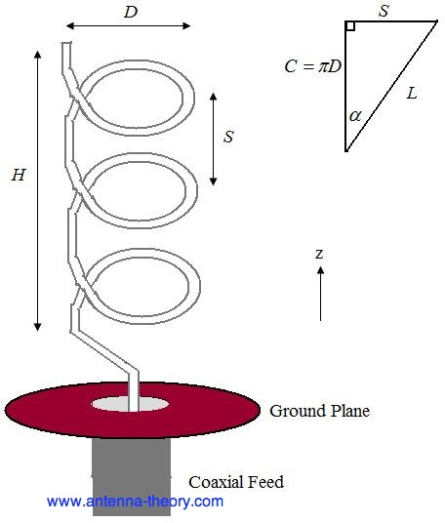

The parameters of the helix antenna are defined below.

• *D* - Diameter of a turn on the helix antenna.

• *C* - Circumference of a turn on the helix antenna (*C*=pi\**D*).

• *S* - Vertical separation between turns for helical antenna.

• alpha- pitch angle, which controls how far the helix antenna grows in the z-direction per turn, and is given by alphaEq

• *N* - Number of turns on the helix antenna.

• *H* - Total height of helix antenna, *H*=*NS*.

The antenna in the above figure is a left handed helix antenna, because if you curl your fingers on your left hand around the helix your thumb would point up (also, the waves emitted from this helix antenna are Left Hand Circularly Polarized). If the helix antenna was wound the other way, it would be a right handed helical antenna.

The radiation pattern will be maximum in the +z direction (along the helical axis in Figure 1). The design of helical antennas is primarily based on empirical results, and the fundamental equations will be presented here.

Helix antennas of at least 3 turns will have close to circular polarization in the +z direction when the circumference *C* is close to a wavelength:

circumference of helix antenna

Once the circumference *C* is chosen, the in-equalities above roughly determine the operating bandwidth of the helix antenna. For instance, if *C*=19.68 inches (0.5 meters), then the highest frequency of operation will be given by the smallest wavelength that fits into the above equation, or lambda=0.75*C*=0.375 meters, which corresponds to a frequency of 800 MHz. The lowest frequency of operation will be given by the largest wavelength that fits into the above equation, or lambda=1.333*C*=0.667 meters, which corresponds to a frequency of 450 MHz. Hence, the [fractional BW](http://www.antenna-theory.com/definitions/fractionalBW.php) is 56%, which is true of axial helical antennas in general. The helix antenna is a **travelling wave** antenna, which means the current travels along the antenna and the phase varies continuously. In addition, the input impedance is primarily real and can be approximated in Ohms by:

input resistance or impedance for helix antennas

The helix antenna functions well for pitch angles (pitch antenna) between 12 and 14 degrees. Typically, the pitch angle is taken as 13 degrees.

The normalized radiation pattern for the E-field components are given by:

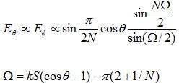

For circular polarization, the orthogonal components of the E-field must be 90 degrees out of phase. This occurs in directions near the axis (z-axis in the above Figure) of the helix. The [axial ratio](http://www.antenna-theory.com/definitions/axial.php) for helix antennas decreases as the number of loops *N* is added, and can be approximated by:

axial ratio of helix antennas

The gain of the helix antenna can be approximated by:

gain of helical antenna

In the above, *c* is the speed of light. Note that for a given helix geometry (specified in terms of *C, S, N*), the gain increases with frequency. For an *N*=10 turn helix, that has a 0.5 meter circumference as above, and an pitch angle of 13 degrees (giving *S*=0.13 meters), the gain is 8.3 (9.2 dB).

For the same example helix antenna, the pattern is shown in Figure below.

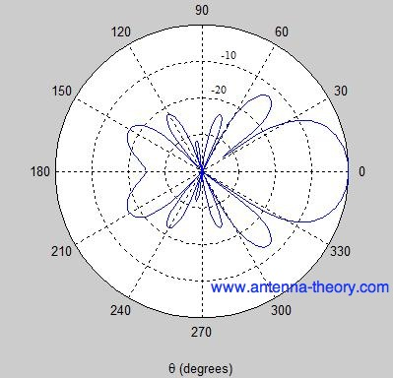

The Half-Power Beam width for helical antennas can be approximated (in degrees) by:

